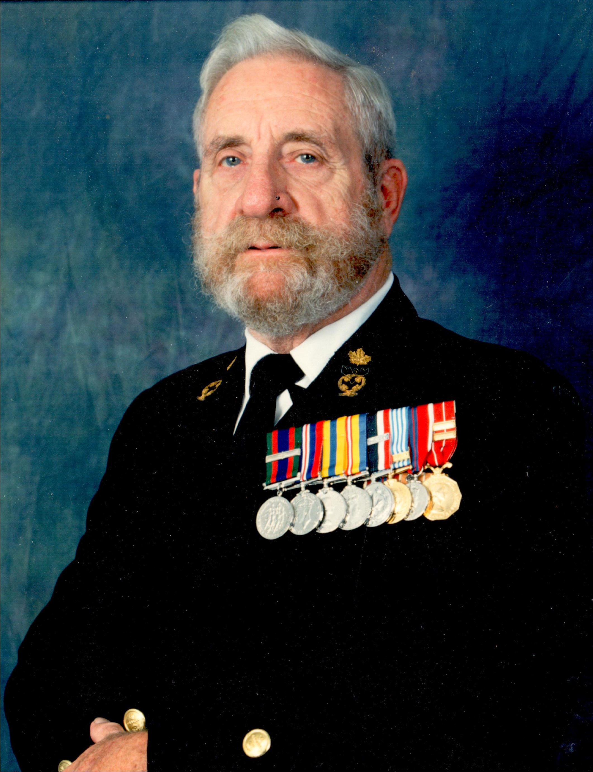

Thomas Anthony (Terry) Sawyer CPO. RCN. Ret’d
Veteran of WWII and Korea
1926-08-31 to 2013-09-06

Tom (Terry) Sawyer has now, at the age of 87, followed those of his shipmates from HMCS Warrior, Cornwallis, Donnacona, Swansea, Sioux, La Hulloise, Stadacona, Granby, Magnificent, Prestonian, Nootka, New Waterford, Montcalm, Assiniboine, and Discovery, HMS Dolphin, HM submarines Andrew, Alcide, and Aeneas, and HMC S/M Ojibwa, who have ‘crossed the bar’ before him. For 50 years, the Navy was his life. Through the ranks to chief electrician, communicator (coder), ship’s diver, submariner, rifle team instructor, Bisley shot, and on ‘civvie’ street, captain of Horton Maritime Explorations Ltd.’s submarine Auguste Piccard, and DND QA and electrical officer for the refit of Navy ships in BC and Ontario. Post-retirement he worked on the restoration of a Swordfish at Downsview, and the restoration of electrical systems on HMCS Haida, as well as volunteering at the Oakville Humane Society.

To those in the Canadian and Royal Navies and the numerous Naval Associations to which Tom belonged, please have a ‘tot’ in memory of Tom and all those who have crossed the bar before. Among Tom’s last words were “No tears, no tears”.

He leaves behind his wife Laine and children Carolyn, Allen, Christopher, and Timothy, and granddaughters Emily and Jessica.
Tom wrote his own epitaph. In fact he wrote two versions of it:
Here lie the ashes of Thomas A. Here lie the ashes of Thomas A.
For him death held no terrors. For him death held no terrors.
Married thrice, the last was nice, Married thrice, the last was nice,
Seven hits, five runs, two errors. Three hits, one run, two errors.

At Tom’s request, a wake was held Saturday September 14th, at the Oakville Royal Canadian Legion Branch 114.

In lieu of flowers, Tom’s favourite charities were the Humane Society, the Foodbank, and the Salvation Army.

See also: http://homes.chass.utoronto.ca/~laine/tom/ or http://www.koprivataylor.com/fh/obituaries/home.cfm?&fh_id=11001

