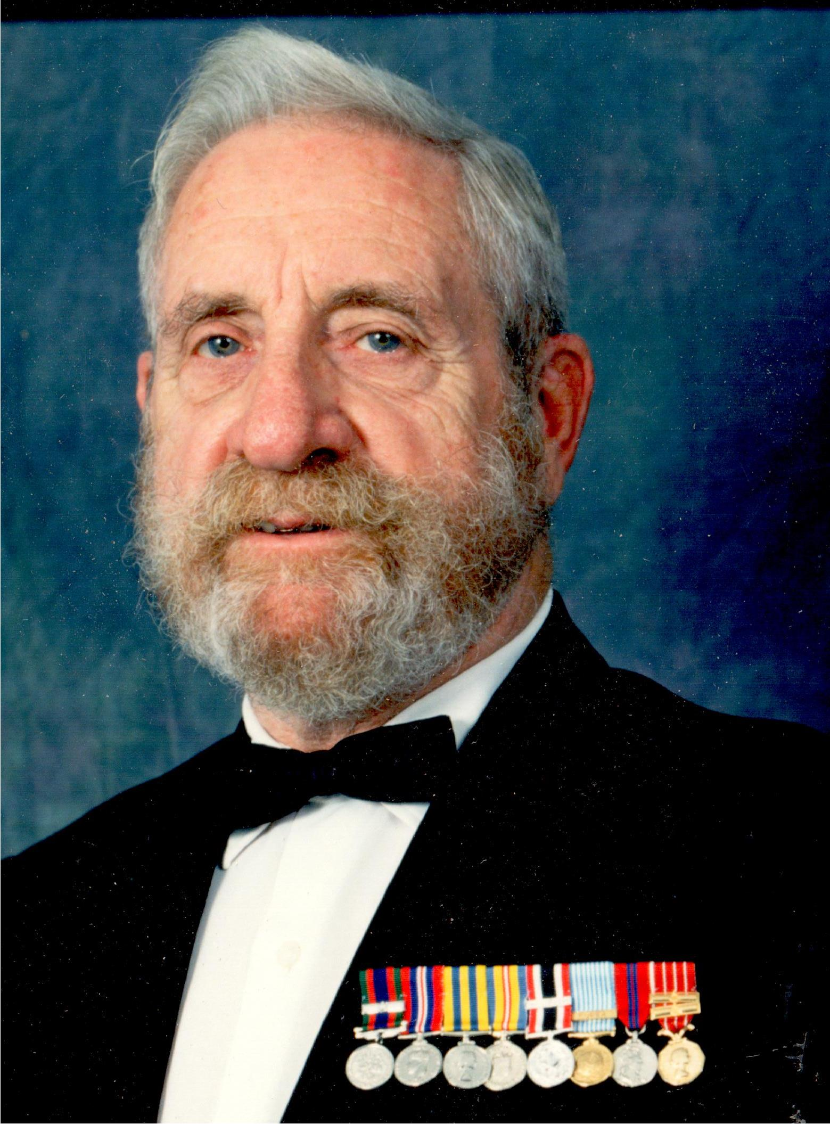

Thomas Anthony (Terry) Sawyer CPO. RCN. Ret’d
Veteran of WWII and Korea
1926-08-31 to 2013-09-06

Tom (Terry) Sawyer has now, at the age of 87, followed those of his shipmates from HMCS Warrior, Cornwallis, Donnacona, Swansea, Sioux, La Hulloise, Stadacona, Granby, Magnificent, Prestonian, Nootka, New Waterford, Montcalm, Assiniboine, and Discovery, HMS Dolphin, HM submarines Andrew, Alcide, and Aeneas, and HMC S/M Ojibwa, who have ‘crossed the bar’ before him. For 50 years, the Navy was his life. Through the ranks to chief electrician, communicator (coder), ship’s diver, submariner, rifle team instructor, Bisley shot, and on ‘civvie’ street, captain of Horton Maritime Explorations Ltd.’s submarine Auguste Piccard, and DND QA and electrical officer for the refit of Navy ships in BC and Ontario. Post-retirement he worked on the restoration of a Swordfish at Downsview, and the restoration of electrical systems on HMCS Haida, as well as volunteering at the Oakville Humane Society. To those in the Canadian and Royal Navies and the numerous Naval Associations to which Tom belonged, please have a ‘tot’ in memory of Tom and all those who have crossed the bar before.

He leaves behind his wife Laine and children Carolyn, Allen, Christopher, and Timothy, and granddaughters Emily and Jessica..
At Tom’s request, friends and colleagues are welcome at a wake at the Oakville Royal Canadian Legion Branch 114, 36 Upper Middle Road East Oakville, Saturday September 14th, from 1 pm (1300 hours) until about 5 pm (1700 hours). There will be a time for reflection at 3 pm (1500 hours). In lieu of flowers, Tom’s favourite charities were the Humane Society, the Foodbank, and the Salvation Army.
See also: http://homes.chass.utoronto.ca/~laine/tom/ or http://www.koprivataylor.com/fh/obituaries/home.cfm?&fh_id=11001

